

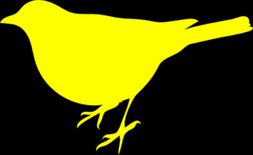Team **Yellow bird**:

* **vyarah** - Вяра Христова
* **shoko** - Деница Димитрова
* **Bruno** - Борис Тончев
* **LaForce** - Александър Овчаров
* **Ivan_Chervenkov** - Иван Червенков

Description:

A SPA resembling IMDB’s functionality.

Used APIs:

jQuery, SystemJS, Babel, Handlebars, Sammy, Underscore, Twitter Bootstrap, Parse,.

[***https://github.com/Yellow-bird/TheMovieShack***](https://github.com/Yellow-bird/TheMovieShack)